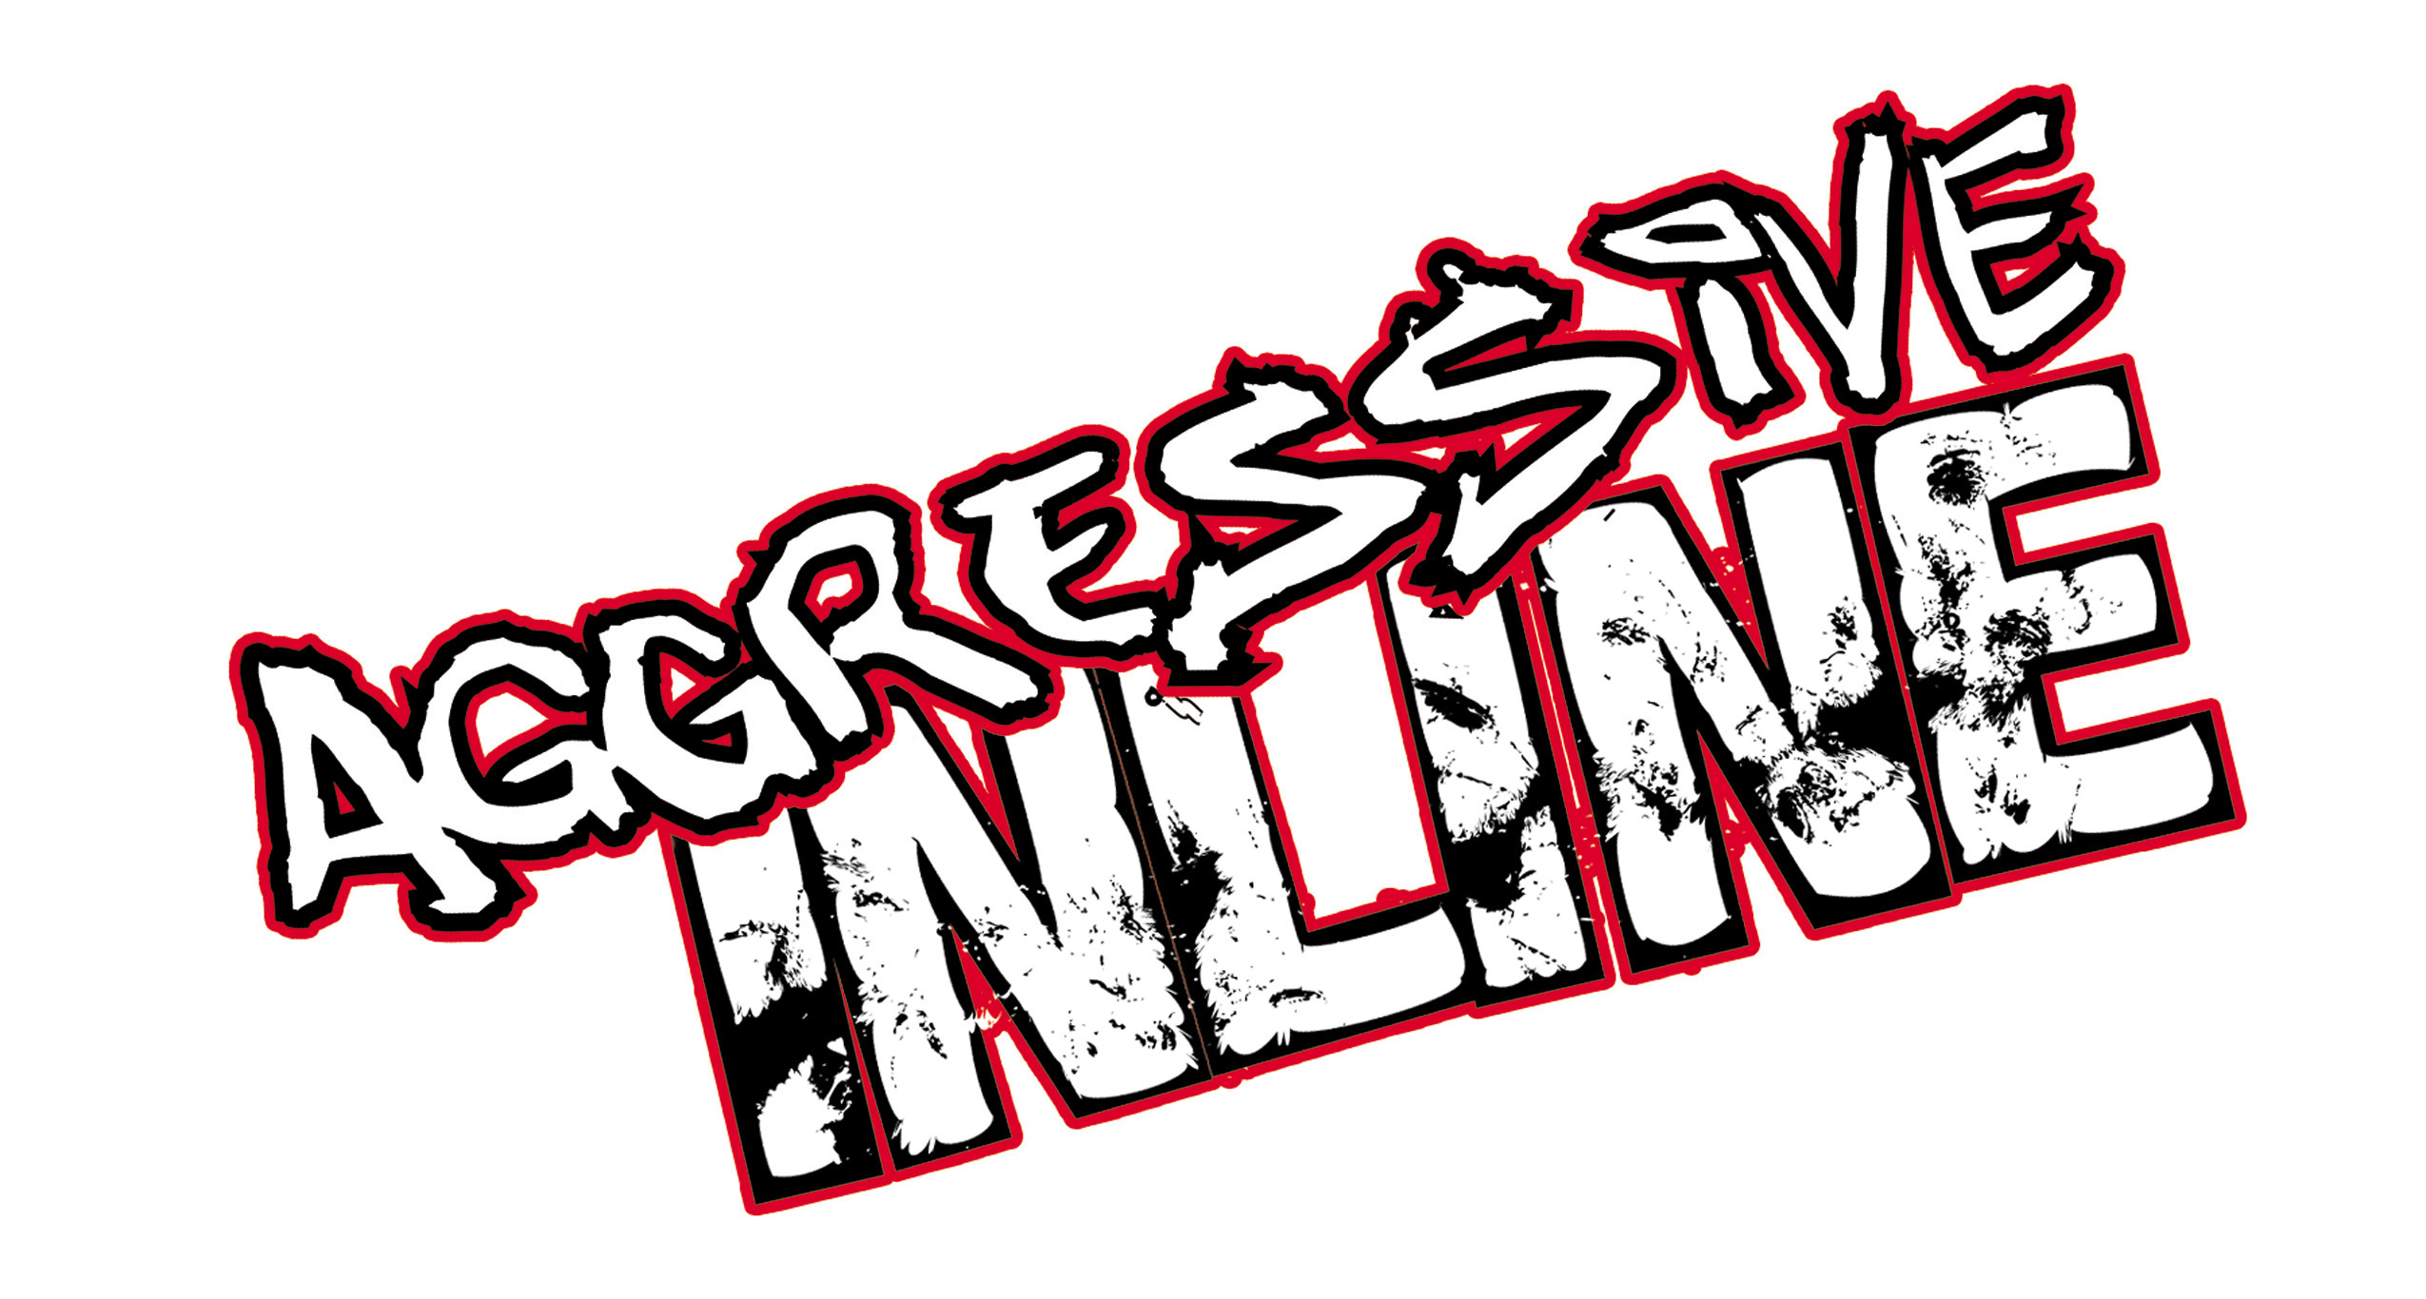
Publisher: Acclaim Entertainment
Developer: Z-Axis
Platform(s): Xbox™
Shipping: August 2002
ESRB Rating: ‘T’ Teen
PR Contact Alan B. Lewis
Acclaim Entertainment, Inc.
(516) 656-2263
alewis@acclaim.com

OVERVIEW
- The first authentic aggressive inline skating game.
- 10 top pro skaters, featuring founding father Chris Edwards, Taig Khris, Frankie Morales, Shane Yost, Eito Yasatoko, Jaren Grob, Matt Lindenmuth, Matt Salerno, and Sam Fogerty.
- The best looking, best playing, most innovative extreme game ever!

GRAPHICS
- Driven by Z-Axis’ 2nd generation graphics engine—monstrous, shockingly detailed levels more than twice the poly count of Mirra 2’s levels, running at 60 fps.
- Intricate character models utilizing Z-Axis’ new dynamic cloth technology, a first for extreme games.
- Super smooth character animations using hundreds of motions captured from our pro skaters at Woodward.
- Female skaters with dynamic skirts, hair and, um, chests.
- Completing challenges rewards players with elaborate in-game cinematics that dramatically alter the level and its gameplay.

GAMEPLAY
- This is not Mirra 2 on skates. Z-Axis designed a new trick system and created a new physics model specifically for inline skating.
- Intense focus on having the best grind game ever—tons of transfers and huge, fast lines throughout the levels, plus the dynamic grind modifier.
- Giant air game with Cess Slide that links to 4 different manuals for building huge combos.
- Intuitive controls with accelerate on the X button *and* the D-pad appeals to both Hawk and Mirra fans.
- Huge arsenal of tricks, including air tricks, grabs, flips, vaults, pole spins, stalls, wall rides, fast plants, cess slides, manuals, and skitches.
- Environments are absolutely jam-packed with trick lines and wacky NPCs who talk to you and dare you to do funny, crazy challenges.

INNOVATION

Action Button – Enables players to Vault off objects, Spin around horizontal and vertical poles, Skitch on moving vehicles, Talk to pedestrians, and Bail out of imminent crashes.
- Dynamic Attribute System – Entirely new RPG-inspired experience system means the growth and improvement of your skater is a reflection of your performance and play style!
- 1-On-1 Battle Bowl – Trick Attack against AI-driven pro skaters for the first time ever.
- Dynamic Grind Modifier – Link any of the 40+ grinds into each other on the fly.
- Integrated in-game Park Editor – Add your own level geometry to the game’s levels as part of the in-game challenges. (You can also create your own stand-alone skate parks.)
- Juice Meter – There is no count-down clock like in Hawk and Mirra. Instead, when you run out of juice, the game is over and you have to replay the level. This adds suspense and motivates the player to find new, creative trick lines. If the player maxes out the juice meter by executing killer tricks, his skates shoot fire trails, he goes faster, and can do Specials.
- Split-Screen Multiplayer – Challenge your buddies to a slew of rockin’ new split-screen multiplayer games such as 21, Power-up Challenge, and Animal Rescue.

